CREATE AN ACCOUNT IN NUTRITION API

SOBHRA RS

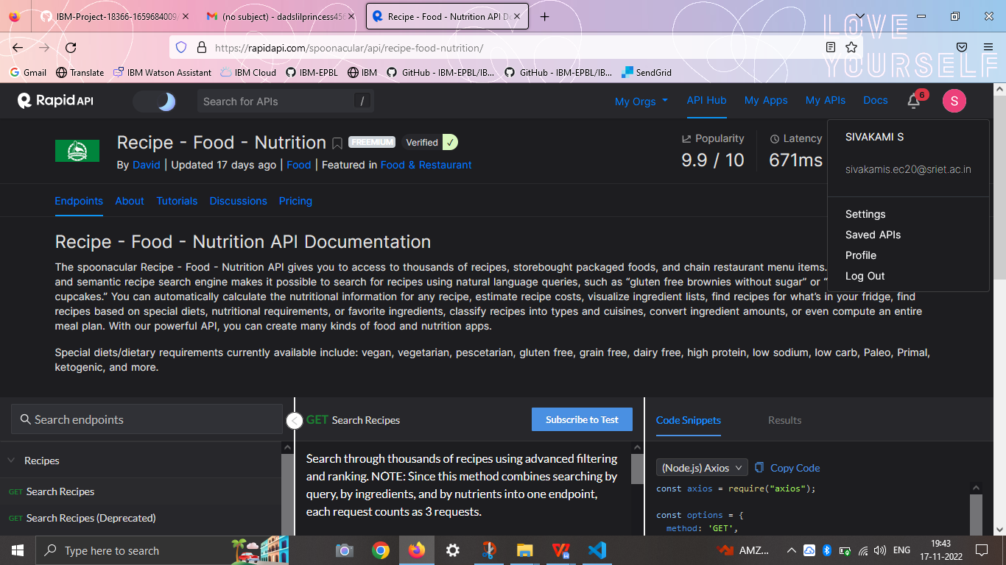

SAHAYA NISHIMA

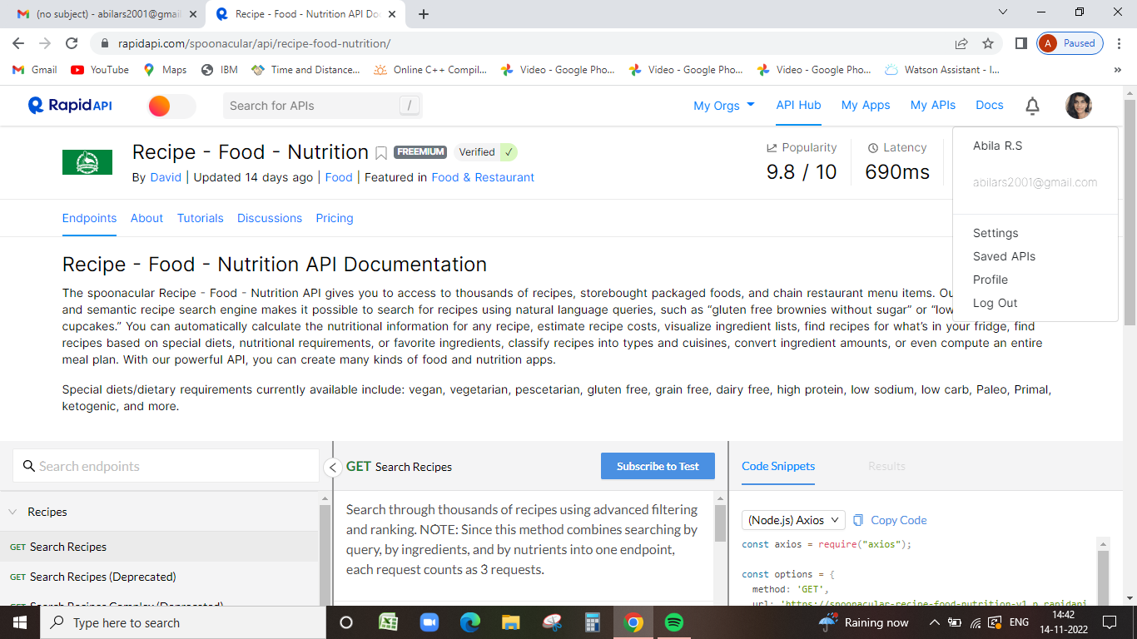

RENI SHAJILA

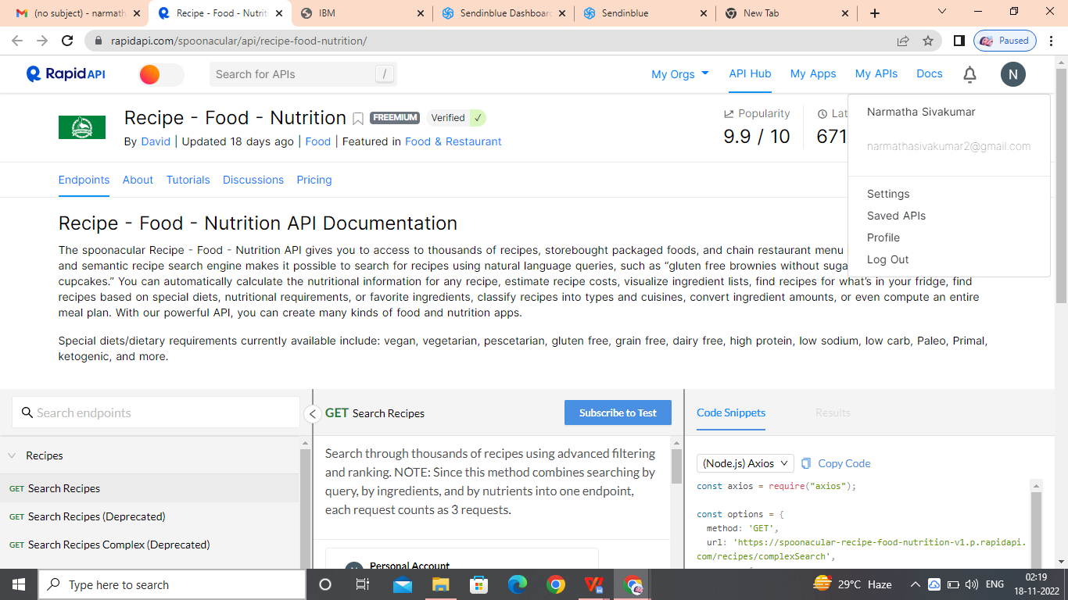

SWEETLIN SAJONY JOY

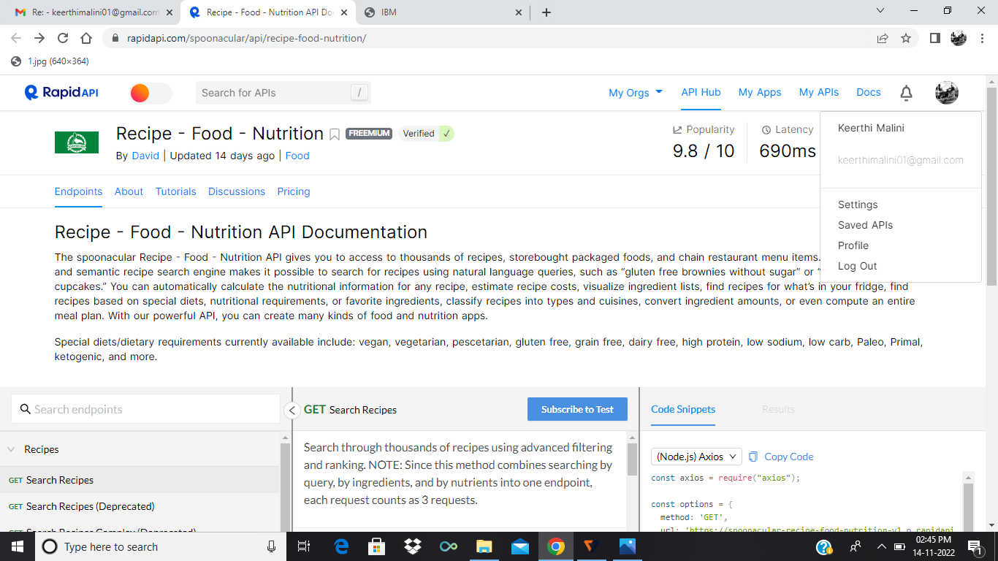

SAHAYA NISHIMA

